# National FASD Program

# National FASD Program

## Overview

FARE received funding from the Australian Government Department of Health to develop and deliver the National Awareness Campaign for Pregnancy and Breastfeeding Women (the Campaign) from July 2020 to September 2024.

Launched in November 2021, the National Campaign aims to:

* increase Australians’ awareness of the risks associated with alcohol consumption during pregnancy and while breastfeeding, including FASD
* increase the proportion of Australians who are aware that alcohol should not be consumed during pregnancy and that is it safest not to drink alcohol when breastfeeding
* increase the proportion of Australian women who intend to not drink any alcohol during pregnancy and when breastfeeding

The National Campaign has four streams:

1. **Stream 1:** general public ([visit the campaign website](https://everymomentmatters.org.au/))
2. **Stream 2:** [priority groups](https://www.nofasd.org.au/) including women at higher risk of alcohol exposed pregnancies
3. **Stream 3:** [health professionals](https://everymomentmatters.org.au/health-professionals/)
4. **Stream 4:** [Aboriginal and Torres Strait Islander peoples](https://www.naccho.org.au/fasd/)

## Steering Committee

The role of the Steering Committee is to provide oversight and expertise during the National Campaign’s development and implementation.

The members of the Steering Committee are:

|  |  |
| --- | --- |
| **Organisation** | **Representing** |
| National Organisation for Fetal Alcohol Spectrum Disorders (NOFASD) | Ms Louise Gray |
| National Aboriginal Community Controlled Organisation (NACCHO) | Ms Dawn Casey PSM |
| Central Coast Local Health District | Mr Steve Ella |
| University of Sydney | Professor Elizabeth Elliott AM |
| Australian College of Midwives (ACM) | Ms Alison Weatherstone |
| Royal Australian College of General Practitioners (RACGP) | Dr Hester Wilson |
| Royal Australian and New Zealand College of Obstetricians, and Gynaecologists (RANZCOG) Immediate Past President | Dr Vijay Roach |
| George Institute for Global Health | Professor Simone Pettigrew |
| Foundation for Alcohol Research and Education (FARE) | Ms Tanya Hosch, Board Director  Ms Caterina Giorgi, Chief Executive Officer |

## National Organisation for Fetal Alcohol Spectrum Disorder (NOFASD)

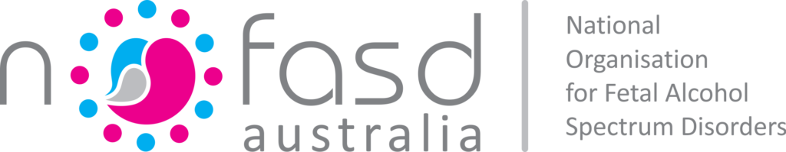

[NOFASD Australia](https://www.nofasd.org.au/) is leading Stream 2 of the National Campaign and will develop and disseminate a suite of prevention and awareness resources specifically tailored to priority groups.

These resources will aim to:

* Increase awareness and understanding of the campaign messages among priority groups.
* Increase knowledge of the risks of drinking alcohol during pregnancy among priority groups.
* Strengthen behavioural intentions of women in the priority groups to not consume alcohol or reduce alcohol consumption during pregnancy.

NOFASD will also provide advice and feedback to FARE on the content and resources produced for the general public stream (Stream 1).

## National Aboriginal Community Controlled Health Organisation (NACCHO)

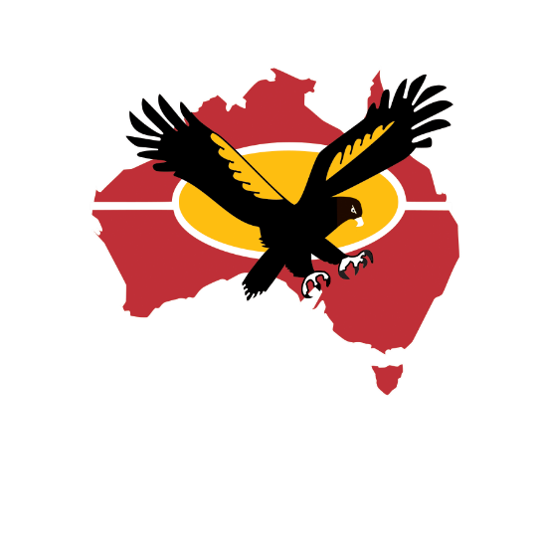

Led by the [National Aboriginal Community Controlled Health Organisation](https://www.naccho.org.au/) (NACCHO), the focus of [Stream 4](https://www.naccho.org.au/fasd/) is to raise awareness among regional and remote Aboriginal and Torres Strait Islander communities of the impacts of alcohol use during pregnancy and while breastfeeding.

To achieve this NACCHO will collaborate with its member organisations and partners to:

* Produce and distribute culturally appropriate resources
* Design and deliver innovative health promotion programs
* Undertake community development projects

NACCHO will also provide advice and feedback to FARE on the content and resources produced for Stream 1, and consult with NOFASD on the content and resources produced for Stream 2.

## Meet the Team

FARE has appointed a passionate and experienced team to coordinate the development and implementation of the National Campaign. We look forward to working collaboratively with colleagues across the country to deliver this incredibly important piece of work.

* Caterina Giorgi, Chief Executive Officer
* Joanna Le, Projects and Partnerships Director
* Dianne Woods, Health Promotion Manager
* Rosemary White, Senior Project Advisor
* Carly Keene, Senior Health Promotion Advisor
* Susan Hickson, Senior Health Promotion Advisor
* Marie Hobden, Senior Health Promotion Advisor

## Stay in touch

You can contact the National Program team at:

* Phone: 02 5104 9311
* Email: [nationalcampaign@fare.org.au](mailto:nationalcampaign@fare.org.au)