# Alcohol during pregnancy

# Alcohol and pregnancy

## At every stage of pregnancy, any alcohol consumed passes directly to the developing baby

# Alcohol and pregnancy

## At every stage of pregnancy, any alcohol consumed passes directly to the developing baby

## Alcohol's impact on a developing baby

For the health of both mum and baby, it is important to have an alcohol-free pregnancy. This is because alcohol can affect your pregnancy and damage the developing baby from conception.

Alcohol can affect your pregnancy and damage the developing baby from conception. Here’s how:

* Alcohol consumed during pregnancy passes from the mother's blood to the baby's blood via the placenta.
* The baby's brain starts developing very early in pregnancy, often before someone knows they are pregnant.
* Drinking alcohol while pregnant increases the risk of miscarriage, stillbirth, and babies being born prematurely, being small for gestational age, or with low birth weight.
* When alcohol is consumed during pregnancy, a developing baby’s blood alcohol level will increase as the mother’s blood alcohol level increases.
* Alcohol can cause damage to a developing baby's brain, body and organs. It can lead to a preventable, lifelong disability called Fetal Alcohol Spectrum Disorder (FASD).

https://www.youtube.com/watch?v=qTk7kETJYkY&ab\_channel=FAREAustralia

## Alcohol can affect fertility

Alcohol can affect fertility and increase the time it takes to get pregnant.

Even small amounts of alcohol can disrupt the menstrual cycle.

This can affect the quality and release of eggs to be fertilised.

Alcohol can also reduce the number or quality of sperm, reducing your chances of conception and increasing the time it takes to get pregnant.

https://www.youtube.com/watch?v=7SGdcjAAtg8

## So, the moment you start trying is the moment to stop drinking

Most people don’t know the moment they become pregnant.

So, if you’re planning a pregnancy, it is important to stop drinking alcohol as soon as you start trying.

### Lauren shares her alcohol-free pregnancy journey

When Lauren and her husband Phil began trying for a baby, the couple made the conscious decision to go alcohol-free for their pregnancy journey.

[Read Lauren’s story](https://staging.wph.org.au/laurens-story/)

We share detailed information about alcohol, pregnancy and FASD on our Every Moment Matters website.

[Find out the importance of alcohol-free pregnancy](https://everymomentmatters.org.au" \t "_blank)

## Facts at a glance: Alcohol and pregnancy

Alcohol can cause at least **damage a developing baby’s brain, body and organs.** It can lead to a preventable disability known as Fetal Alcohol Spectrum Disorder (FASD). Alcohol **increases the risk** of miscarriage, stillbirth, and babies being born prematurely, being small for gestational age, or with low birth weight. The moment you start trying to get pregnant is the moment to **stop drinking alcohol** to avoid damage to the developing baby. The baby’s brain starts developing very early in pregnancy, **often before someone knows they are pregnant.** Alcohol can **damage the organs and systems** of the developing baby’s body, including the brain. Alcohol consumed during pregnancy **passes from the mother’s blood to the baby’s blood** via the placenta. When alcohol is consumed during pregnancy, **a developing baby’s blood alcohol level will increase** as the mother’s blood alcohol level increases.

## Sharing your decision with others

If you drink alcohol, stopping can lead to questions from the people around you – especially if they don’t know you’re planning a pregnancy.

Here are some ideas for what you can say if asked why you’re not drinking:

I'm not ready to share I'm happy to tell people Try saying:"I'm on a health kick and have given up alcohol."Try saying:“I have a big day tomorrow, so no thanks.”Try saying:“No thanks, I’m not drinking tonight.” Try saying:“No thanks, we’re trying for a baby.”Try saying:“I might be pregnant, so no thanks.”Try saying:“No thanks, not while I’m planning a pregnancy.” Try saying:"I'm on a health kick and have given up alcohol."Try saying:“I have a big day tomorrow, so no thanks.”Try saying:“No thanks, I’m not drinking tonight.” Try saying:“No thanks, we’re trying for a baby.”Try saying:“I might be pregnant, so no thanks.”Try saying:“No thanks, not while I’m planning a pregnancy.”

## Getting help if you drink alcohol while pregnant

If you drank alcohol before you knew you were pregnant and are concerned, or if you are currently pregnant and are having trouble stopping drinking, talk to your doctor, midwife, or obstetrician.

Health professionals speak to lots of people about alcohol. They can answer your questions and provide information specific to your circumstances. It is never too late to stop drinking alcohol during pregnancy. Throughout your pregnancy the baby is always developing and growing.

[Pregnancy support services](https://staging.wph.org.au/resources/support/" \l "anchor4)

More information

## Related information

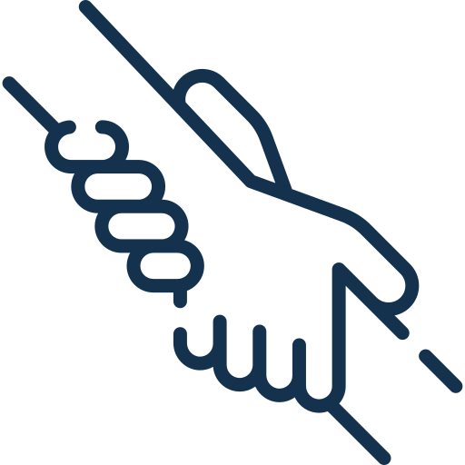

## Need advice or support?

To find a local GP, you can call 1800 022 222 or visit [healthdirect.gov.au](http://healthdirect.gov.au). To find a local psychologist, visit [psychology.org.au/find-a-psychologist](http://psychology.org.au/find-a-psychologist). If you need other support to reduce your drinking, you can contact the National Alcohol and Other Drug Hotline on 1800 250 015.

## Join our community

Will you join the community taking action on alcohol?